Lab exercise
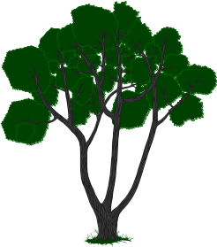

Treestats

Background:

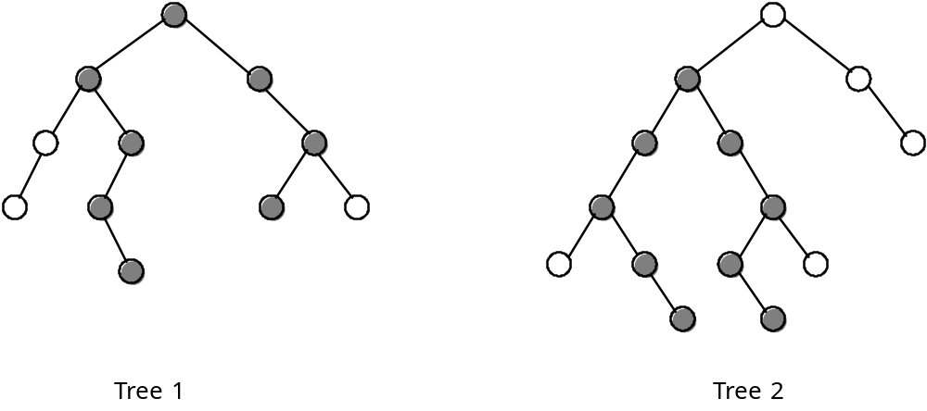

The height of a binary tree is defined as the number of nodes in the longest path from the root to a leaf of the tree. The heights of the trees above are 5 and 6 for Tree 1 and Tree 2, respectively.

The width of a binary tree is the number of nodes in the longest path in the tree. The width of an empty tree is 0; the width of a single-node tree is 1; and the width of Tree 1 is 8 (darkened nodes) and the width of Tree 2 is 9. The longest path may or may not include the root node. In general, the width of an empty tree is 0 and the width of a nonempty tree is the maximum of the following three quantities:

1. The width of the left subtree
2. The width of the right subtree
3. The length of the longest path that includes the root (which can be calculated from the heights of the left and right subtrees).

Assignment:

1. Write a main menu module with the following menu choices:

(1) Fill the tree from a file
(2) Preorder output //note: when printing letters, please leave one space between each
(3) Inorder output
(4) Postorder output
(5) Count nodes in the tree
(6) Count leaves in the tree
(7) Height of the tree
(8) Width of the tree
(9) Clear the tree
(10) isDescendant
- deleteLeaves
- DeleteNode // deletes that node and keeps the tree a ordered binary tree
(-1) Quit

2. Your task is to systematically code and test each of these functions. The data stored in this tree will be a single letter. The source of the letters will be a file consisting of one line of capital letters: (fileA.txt)

3. You should also print appropriate messages, labeling each output.

Instructions:
1. Make these two text files to help you debug (see p.1 for anwers for height/width for these):

(fileA.txt) = KECAJGHOSRV
(fileB.txt) = QJHBADFKNLMPTW

